ROQ Cheatsheet
- What is ROQ?
- ROQ = Reduced order quadrature. It's a type of numerical integration related to other methods such as Gaussian quadrature.
- Lets us calculate fast likelihoods and get PE finished 8 - 300 times faster than with normal likelihood evaluations
- Available waveforms: IMRPhenomD, IMRPhenomPv2, IMRPhenomPv2_NRTidalv2, and IMRPhenomXPHM

- How to use
- There are a few arguments to put into your ini file to make this work
- Different likelihood:
- likelihood-type=ROQGravitationalWaveTransient

- You need to specify the ROQ basis that you want to use. It needs to match the waveform, duration and event type that you are analysing. This is an example for an NSBH run with the IMRPhenomPv2 waveform
- roq-linear-matrix=/home/roq/IMRPhenomPv2/low_mass_ratio/basis_64s.hdf5
- roq-quadratic-matrix=/home/roq/IMRPhenomPv2/low_mass_ratio/basis_64s.hdf5

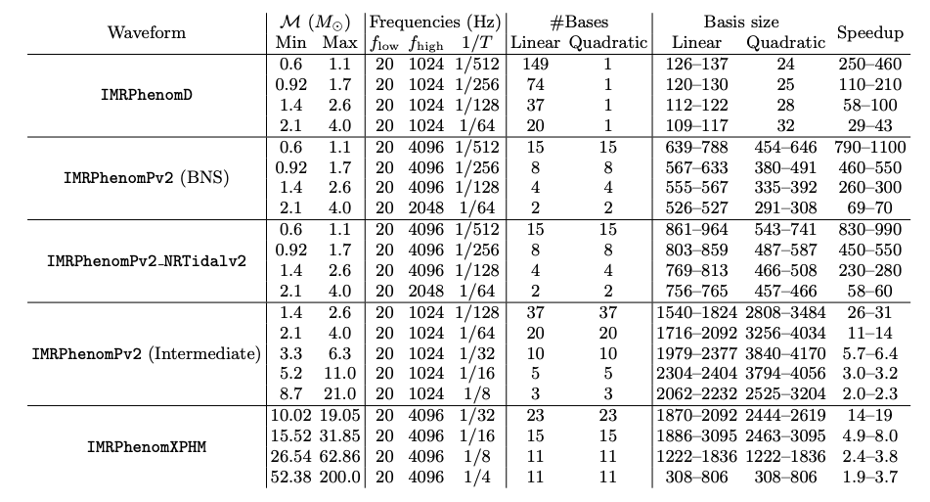
The priors for the chirp mass need to match the duration of the signal and the chosen waveform. For this example I would use the highlighted prior for chirp mass.

- References
- Smith+ 2016, [1604.08253] Fast and Accurate Inference on Gravitational Waves from Precessing Compact Binaries - describes how the ROQ works

- Smith+ 2021, [2103.12274] Bayesian inference for gravitational waves from binary neutron star mergers in third-generation observatories - shows ROQ in action to obtain PE on BNS signals in Cosmic Explorer- really long and loud signals that are difficult with a standard likelihood.

- Morisaki+ 2023, [2307.13380] Rapid localization and inference on compact binary coalescences with the Advanced LIGO-Virgo-KAGRA gravitational-wave detector network - has the prior tables and other details for setting up ROQ jobs

